

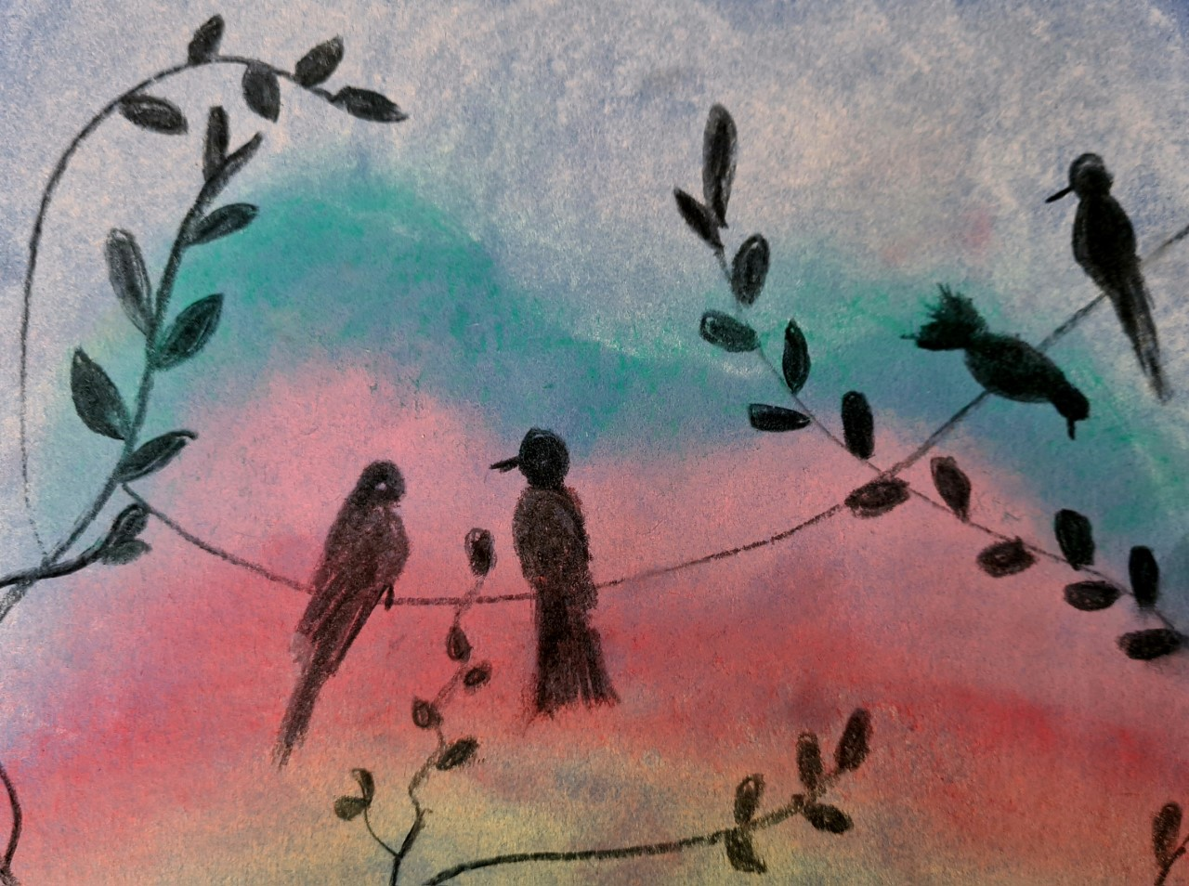

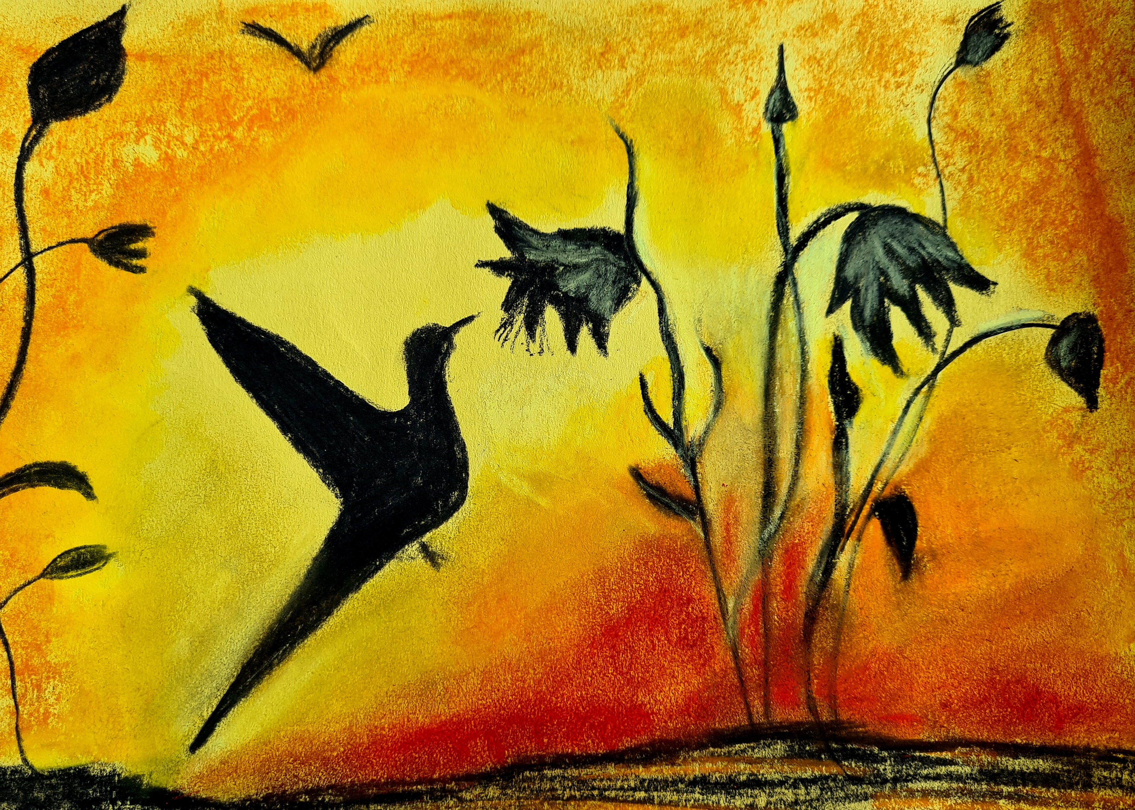

**Old Park School**

**Soft Pastels & Charcoal Workshop**

**Details:** Come along andlearn techniques using soft pastels and charcoal, you will be able to create your own work of art supported by a tutor.

**Date:** Wednesday 14th June (10:00 - 12:00)

**Venue:** Old Park School

**Cost:** Free

**Contact:** School office Tel: 01384 818905